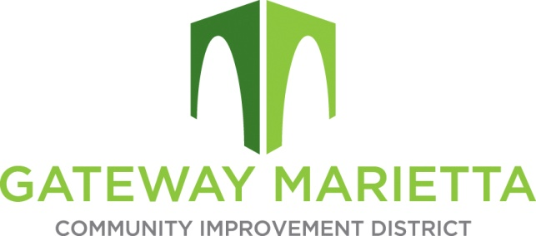

GMCID Board Meeting

Tuesday, July 15, 2025

11:30 AM

1850 Parkway Place Suite 520

Marietta, GA 30067

1. Call to Order
2. Approve Minutes of May 20, 2025, Board Meeting
3. Financial Report
4. City Update
5. Projects Update
   1. Delk Road Quadrants
   2. Blanche Underpass
   3. Digest Projection
   4. Master Plan
6. Adjourn