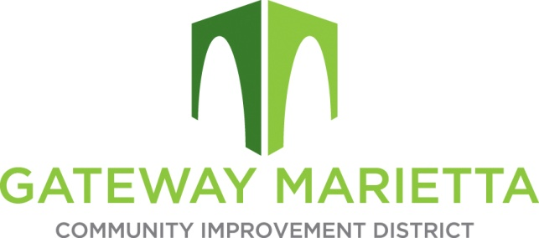

GMCID Board Meeting

Tuesday, May 20, 2025

11:30 AM

1850 Parkway Place Suite 520

Marietta, GA 30067

1. Call to Order
2. Approve Minutes of April 21, 2025, Board Meeting
3. \*\*Break for Caucus of Electors at 11:45 a.m.\*\*
4. Financial Report
5. Discuss Millage Rate
6. City Update
7. Projects Update
   1. Delk Road Quadrants
   2. Flock Cameras
   3. Blanche Underpass
   4. Master Plan
8. Adjourn