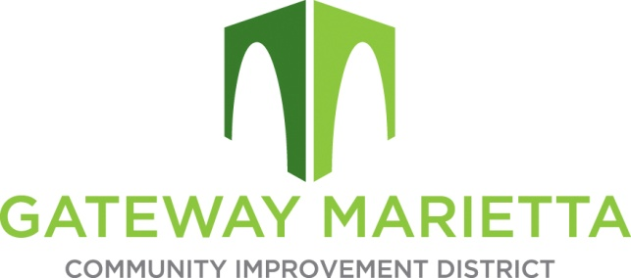

GMCID Board Meeting

Monday, April 21, 2025

1:00 PM

https://us02web.zoom.us/j/88540384628?pwd=yec2BS7PewkUqiwbb1Ha0A6aZMKMqm.1

1. Call to Order
2. Approve Minutes of January 21, 2025, Board Meeting
3. Call for Caucus of Electors
4. Financial Report
5. City Update
6. Projects Update
   1. SMP Quadrants
   2. Delk Road Quadrants
   3. Flock Cameras
   4. Master Plan
7. Adjourn